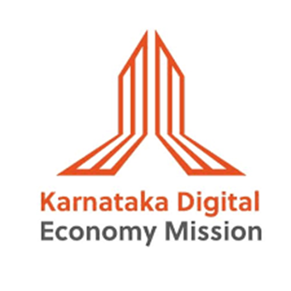
Post Event Report
Prepared by


Summary Dashboard
Metric | Count | Breakdown / Highlights
Total Stories Secured | 25 | 8 Online, 17 Print
Online Coverage | 8 | Tier-1:Times of India, Deccan Herald  Tech-Trade Media :Express Computer, Data quest, CXO Today, Daily Hunt  Regional: VijayaKarnataka & AIN Kannada
Print Coverage | 17 | National English: The New Indian Express, Times of India  Regional Vernacular: Vijayakarnataka, Hosadiganta, Udayavani, Bharatha Vaibhava, Hasirukranti, Moodana, Samyukta Karnataka, Belagavi Varadi, Sakshiprabha, Halliya Sandesha, Janajeevala, Nadoja,Indu Munjane,SanjeMadhyama,Sanjedarpana
Brief Introduction of the Event
Commendations on the outstanding success of HDB Techceleration 2025, a landmark event held on August 22, 2025, at Suvarna Vidhana Soudha, Belagavi. This flagship summit under the Karnataka Digital Economy Mission’s Beyond Bengaluru initiative marked a pivotal milestone in accelerating the growth and transformation of the Hubballi-Dharwad-Belagavi (HDB) cluster into a nationally recognized innovation and manufacturing hub.
The event brought together over 550 delegates, 150+ startups, 40+ global speakers, and 30+ investors, highlighting the cluster’s vibrant ecosystem through 40+ startup showcases, 12+ incubators, 4 product launches, and the felicitation of 3 fund-ready startups and 2 ELEVATE award winners. Strategic collaborations were underscored by the exchange of one MoU and presentation of one Letter of Intent, signaling growing investor confidence in the region.
Noteworthy was the signing of an MoA between three Technology Business Incubators DIMHANS, Maratha Mandal Engineering College Belagavi, and Visvesvaraya Technological University (VTU), each backed by ₹10 crore support from the Government of Karnataka, fostering innovation in sectors spanning AI, agriculture automation, diagnostics, and digital immersive systems. A significant MoU was also exchanged between the National Forensic Sciences University (NFSU) and KDEM, exemplifying strong industry-academia collaboration.
Keynotes included:
- Dr. Sanjay Tyagi, Karnataka Jurisdictional Director, STPI, emphasising Karnataka’s tech ecosystem, AI mission, and MSME digital transformation needs
- Mr. Rahul Sankanur, IAS, Director, KEONICS and MD, KITS, highlighting hardware-driven innovation and the region’s contributions to Karnataka’s IT ecosystem
- Mr. Lakshmi Srinivas Rao, Deputy GM, State Bank of India, announcing SBI’s first-of-its-kind GCC Service Center and innovative credit solutions for MSMEs
- Industry anchors like Mr. Venkatesh Patil and Mr. Santosh Huralikoppi underlining investment momentum and strong local industry-academia-startup linkages
The event not only accelerated innovation but cemented the HDB cluster as a cost-competitive, talent-rich global destination aptly named the “Suvarna Valley of India.”
Media Engagement Highlights:
On the sidelines of the event, we proactively engaged with 9 senior journalists from leading national, regional, and vernacular publications via media rounds a day prior to the event to amplify the impact of KDEM’s work in promoting the HDB cluster. Our strategic media rounds included visits to the offices of key publications such as Samyukta Karnataka, Deccan Herald, Prajavani, Tarun Bharat, Kannada Prabha, Vijayavani, The Times of India, and Vijay Karnataka, where we showcased KDEM’s initiatives and the transformative progress within the HDB cluster.
This hands-on approach resulted in a robust media footprint, with press release-driven coverage securing 25 mentions across both online and print platforms. Tier-1 publications like The Times of India, The New Indian Express, Deccan Herald, Express Computer ,Data Quest and CXO Today led the charge, complemented by significant regional visibility in dailies including Vijayakarnataka, Udayavani, and Hosadigantha.
The team remains committed to tracking and sharing real-time updates as more coverage comes in, ensuring sustained visibility and momentum for the HDB cluster and KDEM’s strategic vision.
Publications in attendance included:
Sr. No. | Name | Publication
1 | Amrutha | Dooradarshan
2 | Ravindra | Times of India
3 | Manjunath | Vijayavani
4 | Ravi Gosavi | Vijay Karnataka
5 | Vijay Kumar | Dep’t of Information & Public Relations
6 | Arun Nesargi | Information Assistant DIPR
7 | Amar Kage | Information Assistant DIPR
Press Release-led Coverage: 25 Coverage
A total of 25 press release-led coverages were secured for HDB Techceleration 2025, comprising 8 online and 17 print coverages with strong national and regional visibility.
- Online coverage featured prominently in tier-1 mainline, and technology publications, including Times of India, Deccan Herald, The New Indian Express, Express Computer, Data Quest, CXO Today, and Daily Hunt. These stories highlighted the unveiling of the ₹1,000+ crore HDB Cluster Vision Document, strategic investments, and the roadmap to 2,500 startups.
- Regional online platforms such as Vijayakarnataka provided focused coverage on the Karnataka Digital Economy Mission’s initiatives driving innovation in Belagavi.
- Print coverage spanned leading English dailies and key regional newspapers including Vijayakarnataka, Hosadigantha, Udayavani, Bharatha Vaibhava, Hasirukranti, Moodana, Samyukta Karnataka, Belagavi Varadi, Sakshiprabha, Halliya Sandesha, Janajeevala,Nadoja, Indu Munjane , SanjeMadhyama and ,Sanjedarpana. These featured in-depth stories on the Techceleration event, startup showcases, incubator signings, and local ecosystem growth.
- Additionally, the event was covered extensively by DD Chandana.
Objective:
- Deepening Belagavi’s positioning as North Karnataka’s innovation and manufacturing hub
- Highlighting robust ecosystem growth, enabling startups, attracting investments, and creating quality jobs
- Showcasing collaborative industry–academia efforts and incubation infrastructure growth
- Setting a trajectory aligned with Karnataka’s economic vision through 2047 and India@100 ambitions
Pre-event activities:
- Preparation and dissemination of the announcement press release.
- Pre-event planning and end-to-end coordination with KDEM
- Coordinating on target media list for national, regional, and vernacular outreach.
- Preparation and dissemination of the media invite.
- Proactive media rounds conducted for event participation and create awareness on Techceleration 2025.
- Securing necessary approvals for the event press release, and invite content
Event activities:
- Media registration and welcome at the venue.
- On-ground media management.
- Press release dissemination
Post-event activities:
- Dissemination of the event press release with Photos along with the draft vision report.
- Sharing coverage updates in real time.
- Preparation of the post-event media coverage report.
- Securing media interaction with regional and national media.
Media Invite:
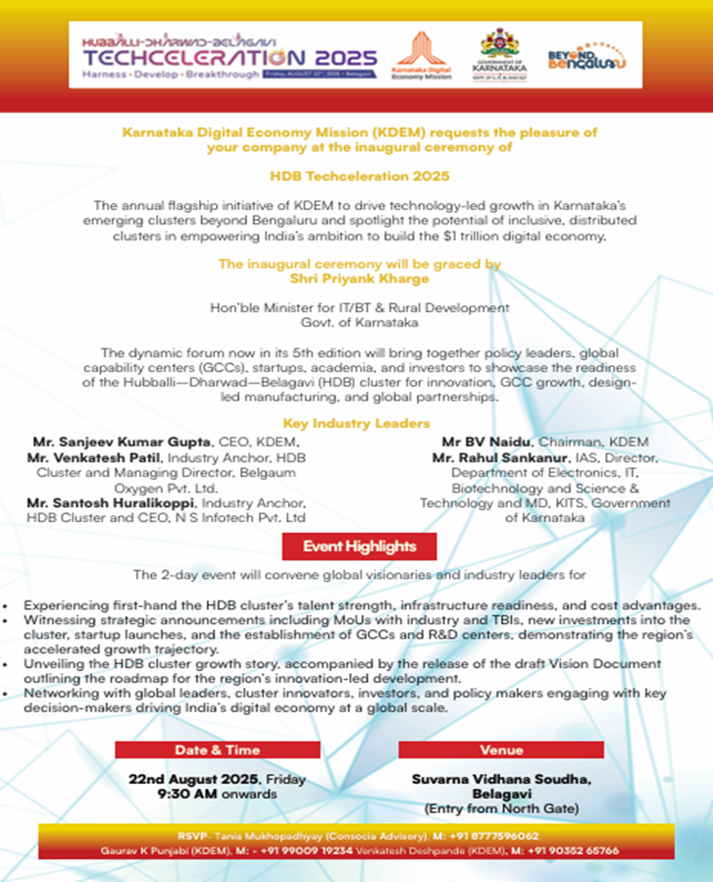

Details at a glance

Event: | The HDB Techceleration 2025
Venue: | Suvarna Vidhana Soudha, Belagavi
Time: | 09:00 am onwards
Client represented by: | Venkatesh Deshpande
Consocia represented by: | Tania Mukhopadhyay & Karthik Soorya

Pictures from the Event
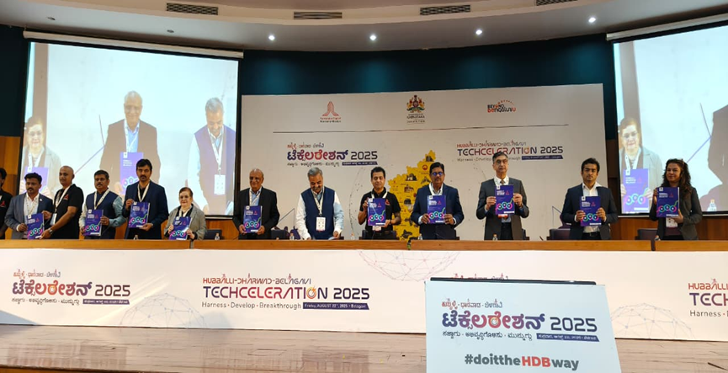
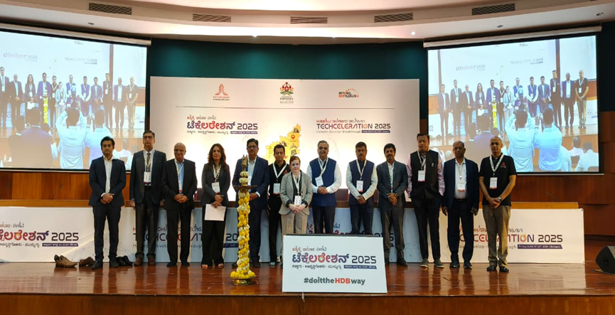

Press Release Copy
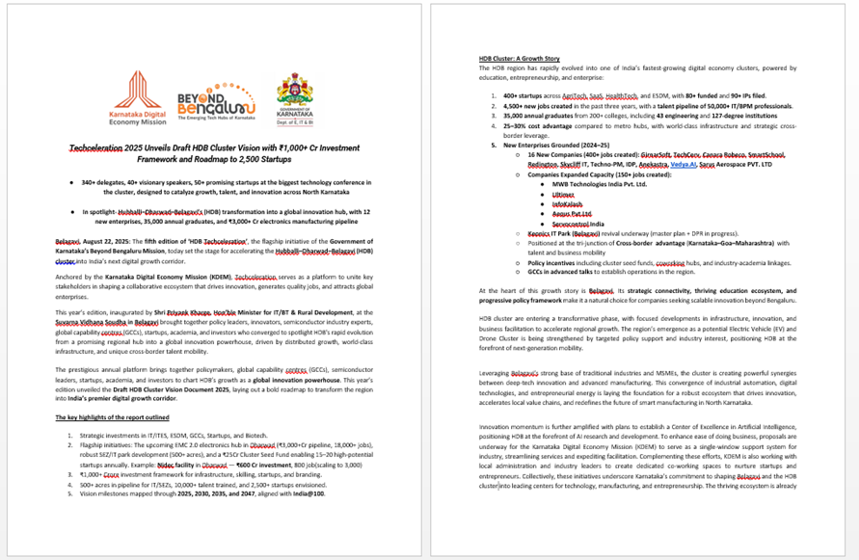
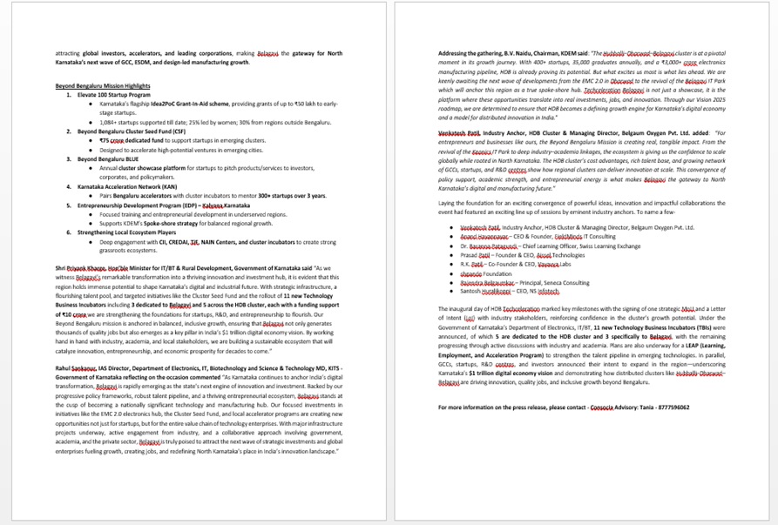

Coverage:
HDB TECHCELERATION 2025 -BELAGAVI
Sr. No. |  |  | Date |  | Publication | Headline + Link | Type/page number
HDB TECHCELERATION 2025 - HUBBALLI – ONLINE
1 | 23rd August 2025 | Times of India |  | MSMEs Urged to Adopt AI for Industrial Growth |  |  |  | Online
2 | 23rd August 2025 | Deccan Herald |  | Karnataka IT/BT Dept announces 11 new business incubators |  |  |  | Online
HDB TECHCELERATION 2025 - HUBBALLI – REGIONAL - ONLINE
1 | 23rd August 2025 | VijayaKarnataka |  | Karnataka Digital Economy Mission: New Initiative to Drive Innovation and Growth in Belagavi |  |  |  | Online
2 | 26th August 2025 | AIN Kannada |  | KDEM will play a key role in driving the state’s digital economy: B.V. Naidu |  |  |  | Online
HDB TECHCELERATION 2025 - REGIONAL - BELAGAVI - PRINT - ENGLISH
1 | 22nd August 2025 | The News Indian Express( Belagavi Edition) |  | KDEM pushes for Belagavi as digital innovation hub |  |  |  | 2
2 | 22nd August 2025 | Times of India(Hubballi,Dharwad & Belagavi Edition) |  | MSMES urged to adopt AI for growth |  |  |  | 3
HDB TECHCELERATION 2025 – ONLINE
Sr. No. | Date | Publication |  | Headline + Link |  |  |  | Type/page number
1 | 22nd August 2025 | Express Computer |  | Techceleration 2025 unveils draft HDB cluster vision with ₹1,000+ Cr investment framework and roadmap to 2,500 startups |  |  |  | Online
2 | 22nd August 2025 | Data Quest |  | Techceleration 2025 unveils draft HDB Cluster Vision with ₹1,000+ cr investment and roadmap to 2,500 startups |  |  |  | Online
3 | 22nd August 2025 | CXO Today |  | Techceleration 2025 Unveils Draft HDB Cluster Vision with ₹1,000+ Cr Investment Framework and Roadmap to 2,500 Startups |  |  |  | Online
4 | 23rd August 2025 | Daily Hunt |  | Karnataka IT/BT Dept announces 11 new business incubators |  |  |  | Online
HDB TECHCELERATION 2025 - REGIONAL - BELAGAVI - PRINT
Sr. No. | Date | Publication |  | Headline + Link |  |  |  | Type/page number
1 | 22nd August 2025 | Vijayakarnataka |  | Hubballi-Dharwad Belagavi Techceleration |  |  |  | 4
2 | 22nd August 2025 | Hosadiganta |  | Hubballi-Dharwad Belagavi Techceleration |  |  |  | 18
3 | 22nd August 2025 | Udayavani |  | All Cooperation for new invention |  |  |  | 3
4 | 22nd August 2025 | Bharatha Vaibhava |  | Hubballi-Dharwad Belagavi Techceleration |  |  |  | 5
5 | 22nd August 2025 | Hasirukranti |  | Hubballi-Dharwad Belagavi Techceleration |  |  |  | 1
6 | 22nd August 2025 | Moodana |  | Hubballi-Dharwad Belagavi Techceleration |  |  |  | 2
7 | 22nd August 2025 | Samyukta karnataka |  | Hubballi-Dharwad Belagavi Techceleration |  |  |  | 9
8 | 22nd August 2025 | Belagavi Varadi |  | Hubballi-Dharwad Belagavi Techceleration |  |  |  | 1
9 | 22nd August 2025 | Sakshiprabha |  | Hubballi-Dharwad Belagavi Techceleration |  |  |  | 1
10 | 22nd August 2025 | HalliyaSandesha |  | Hubballi-Dharwad Belagavi Techceleration |  |  |  | 1
11 | 22nd August 2025 | Janajeevala |  | Hubballi-Dharwad Belagavi Techceleration |  |  |  | 6
12 | 22nd August 2025 | Nadoja |  | Hubballi-Dharwad Belagavi Techceleration |  |  |  | 1
HDB TECHCELERATION 2025 - REGIONAL - DHARWAD - PRINT
1 | 24th August 2025 | Indu Munjane |  | Hubballi-Dharwad Belagavi Techceleration |  |  |  | 2
2 | 24th August 2025 | Sanje Madhyama |  | Hubballi-Dharwad Belagavi Techceleration |  |  |  | 2
HDB TECHCELERATION 2025 - REGIONAL - HUBBALLI - PRINT
1 | 24th August 2025 | Sanjedarpana |  | Hubballi-Dharwad Belagavi Techceleration |  |  |  | 2

*****

